Samarth Rural Educational Institute’s
Samarth College of Computer Science, Belhe
Academic Year 2026-2027(SEM-V)
T.Y.B.Sc. (Information Technology)
Practical NO: 9
Title :9. CRUD Operations using Flask and Database
Roll NO: 70 Batch : C

SET A :

Q1. Student Management System
Create a Flask application connected to database.
Requirements:
- Create a table Student (Student_ID, Name, Course).
- Insert at least 3 student records using an HTML form.
- Display all student records on a web page.
Ans: app.py
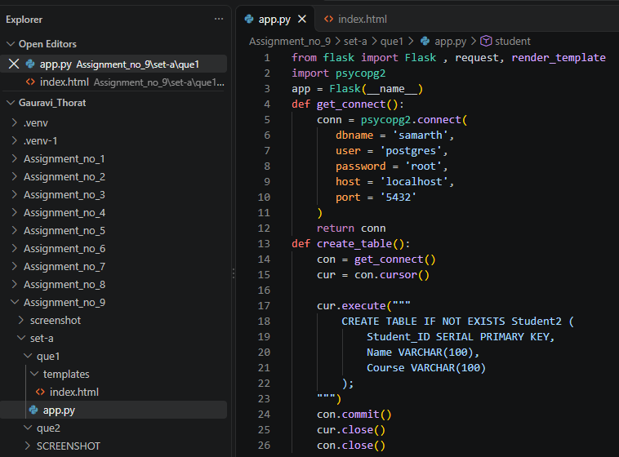
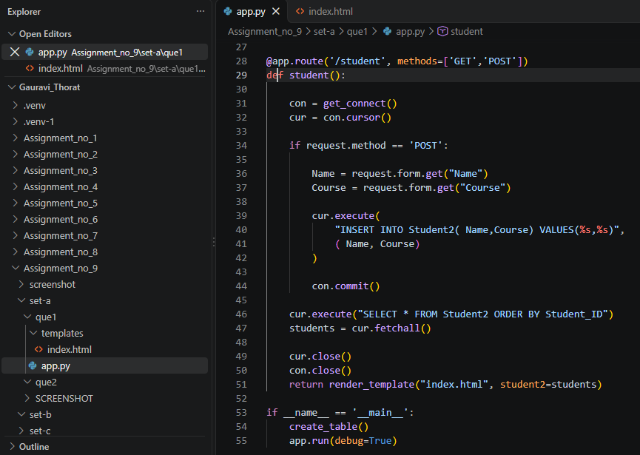
Index.html

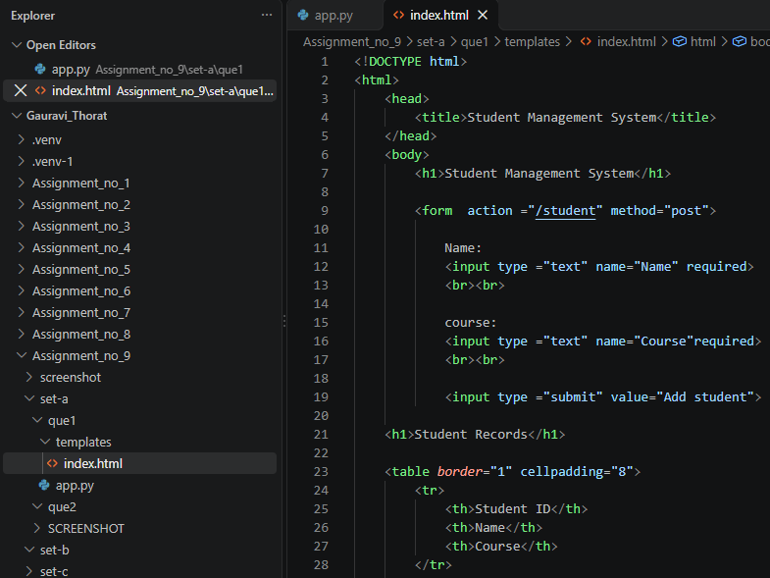
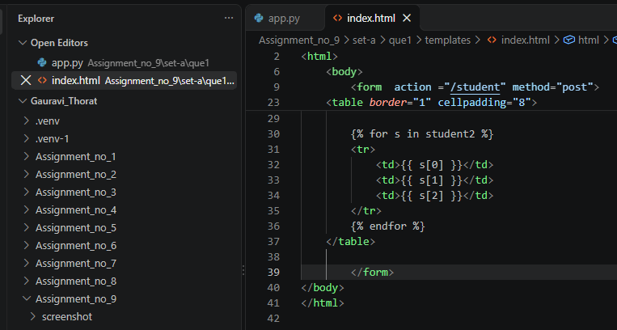
Output:
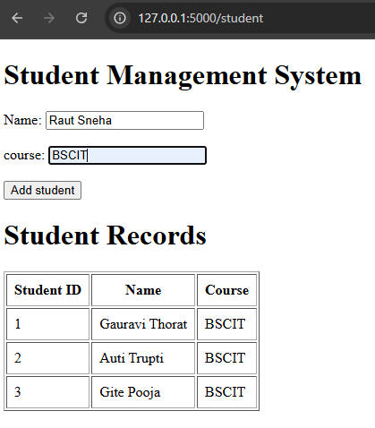

Database:
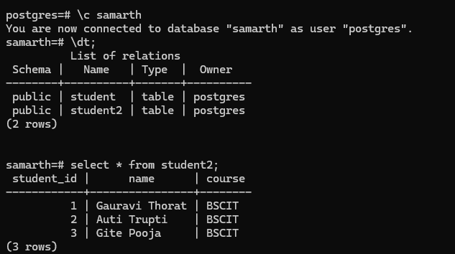

Q2. Employee Management System
Create a Flask application connected to database.
Requirements:
- Create a table Employee (Emp_ID, Name, Department).
- Insert employee records using an HTML form.
- Display all employee records in tabular format.
Ans: app.py
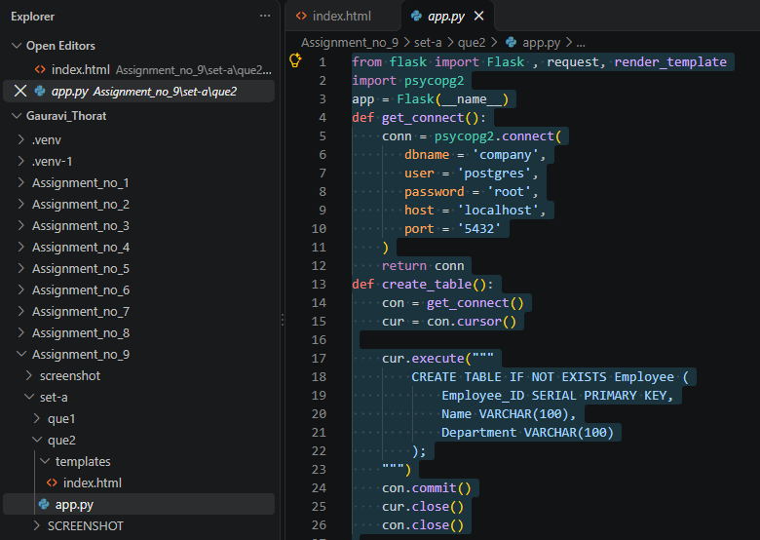
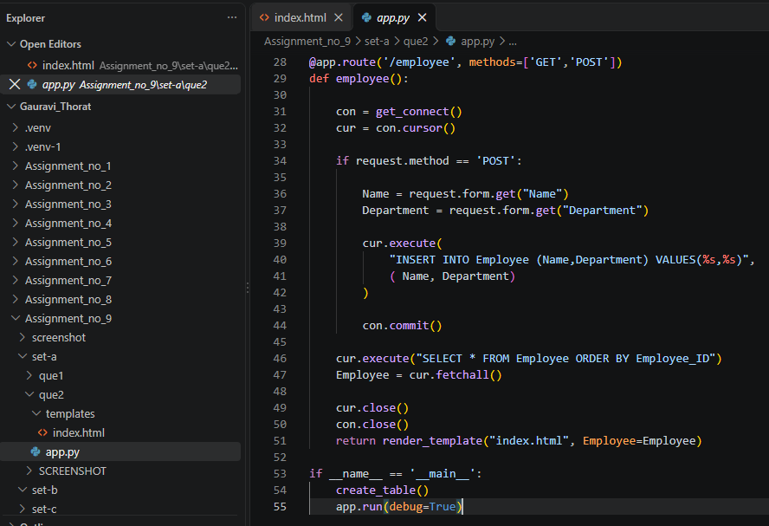
Index.html:
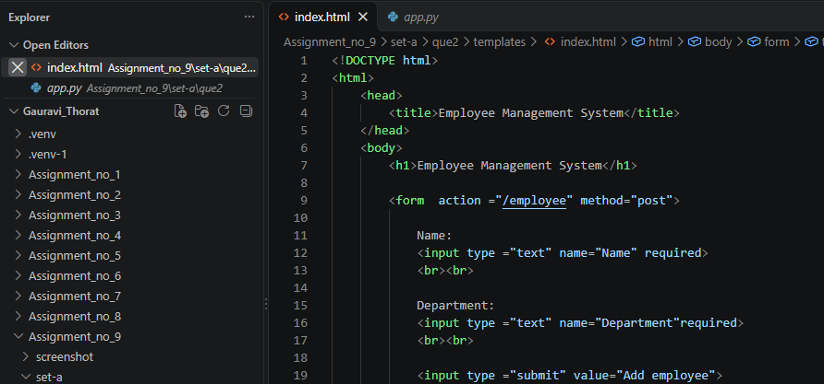
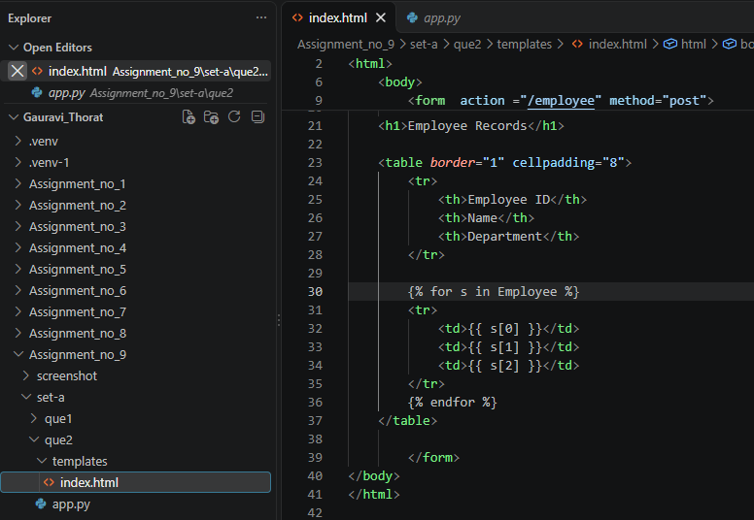

Output:
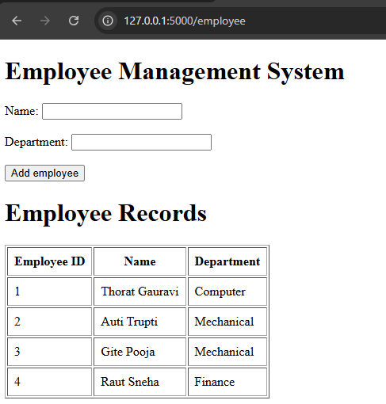
Database:
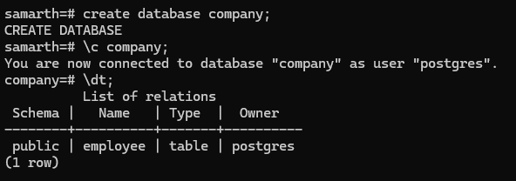
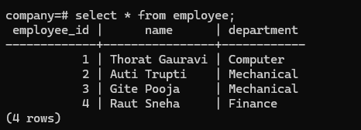

SET B :

Q1. Student Management System with Update Operation Create a Flask application connected to database.

Requirements:
- Create Student table.
- Insert and display student records.
- Update the course of a student using Student_ID.
- Display updated records.
Ans: app.py:
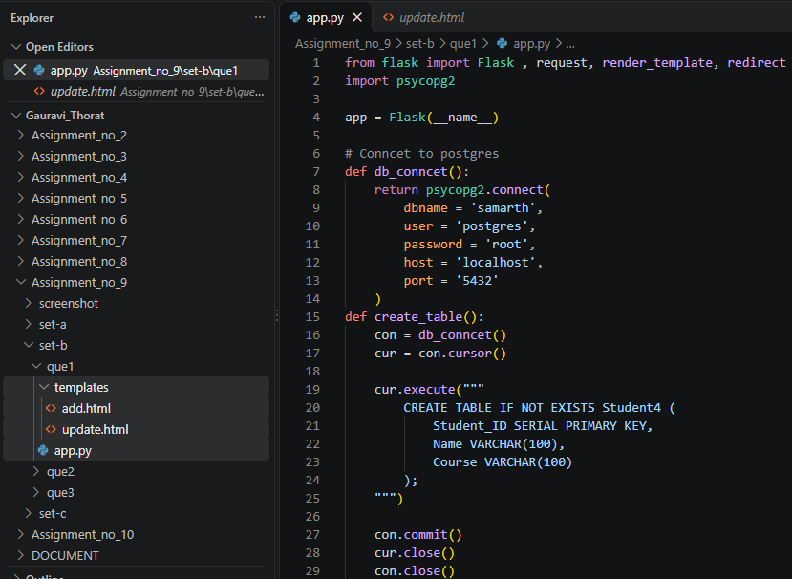
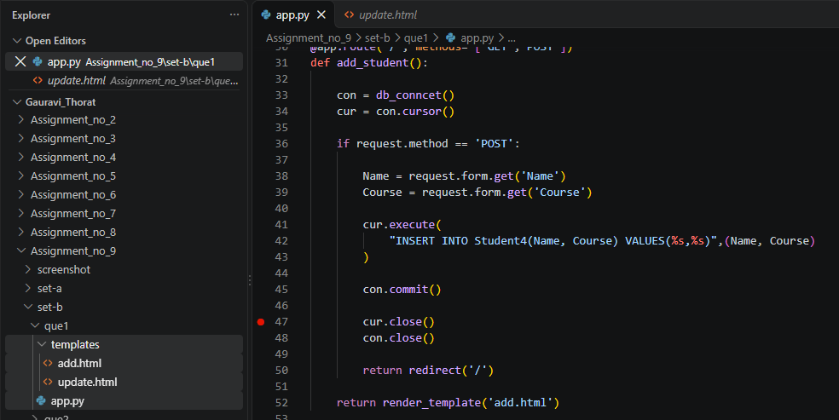
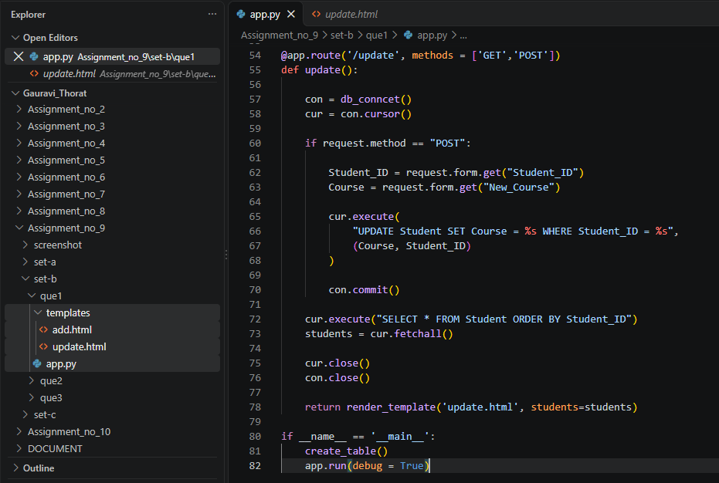
add.html

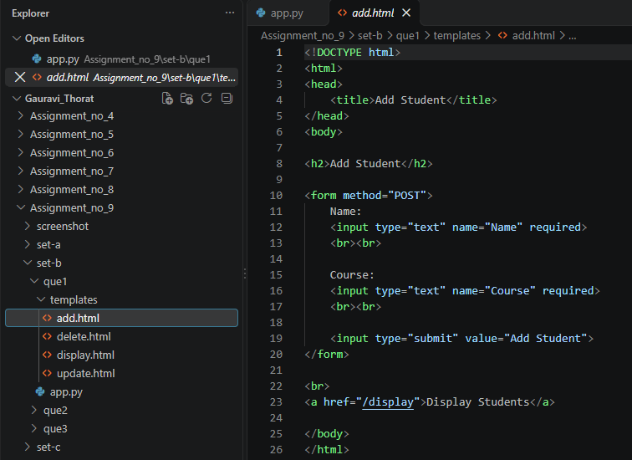
Updata.html
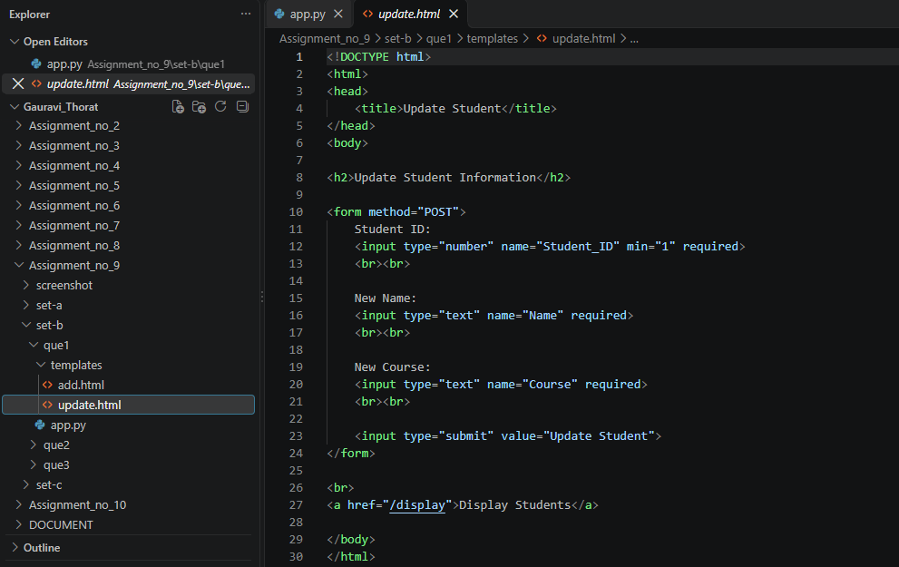
Output:
Add student:
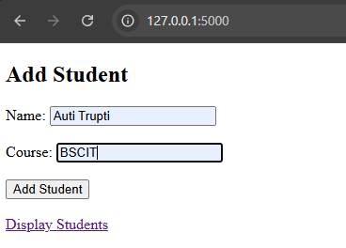
Update student:
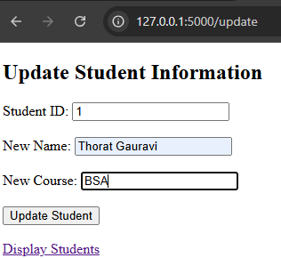

Q2. Create a Flask application to insert, display and update book details using Book_ID and Display updated records.
Ans:
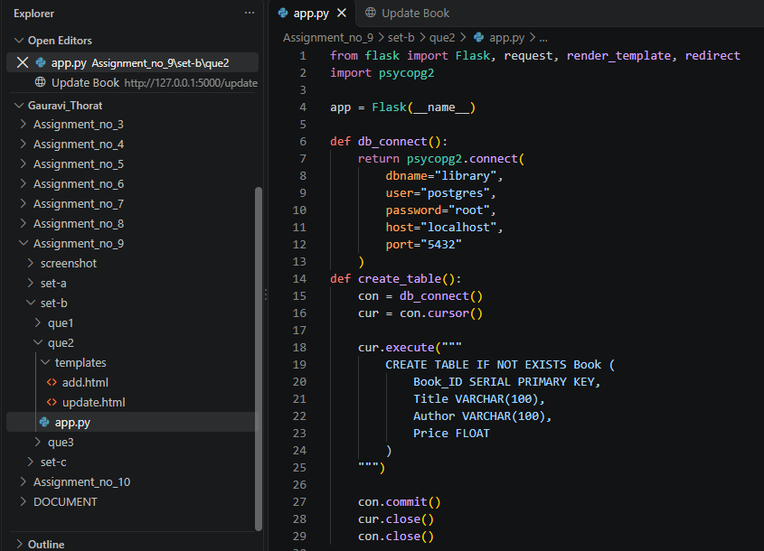
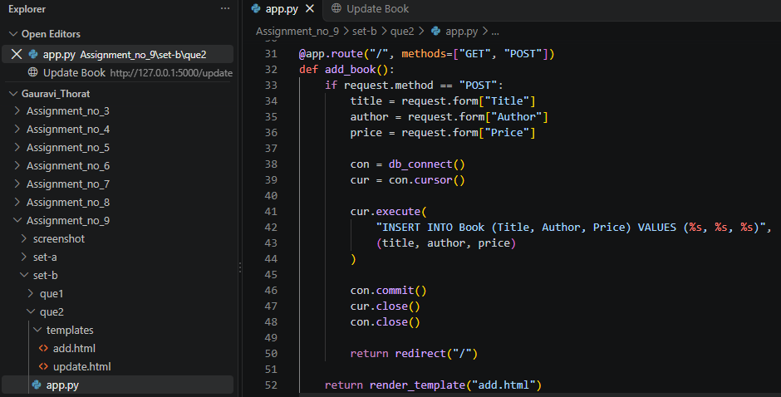
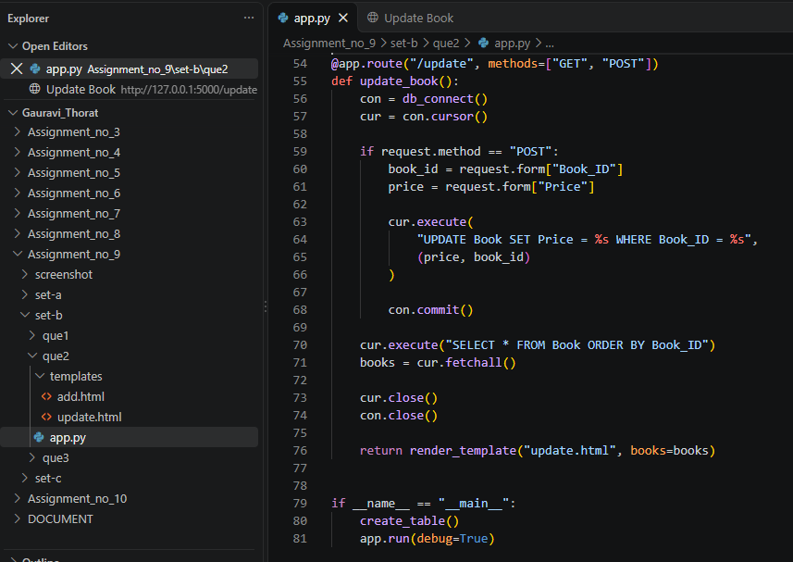
Output:
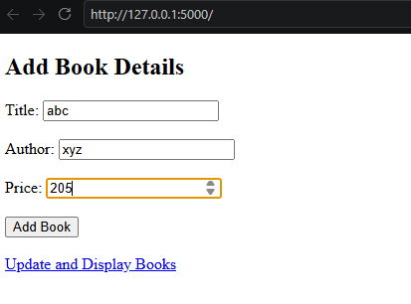
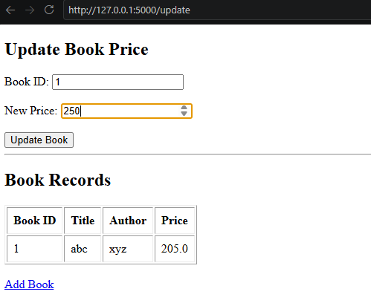

SET C
Q1. Complete CRUD Application
Create a Flask application connected to database.
Requirements:
- Create Student table.
- Insert student records through HTML form.
- Display all records.
- Update student information.
- Delete a student record using Student_ID.
- Display the final updated records.
Ans:
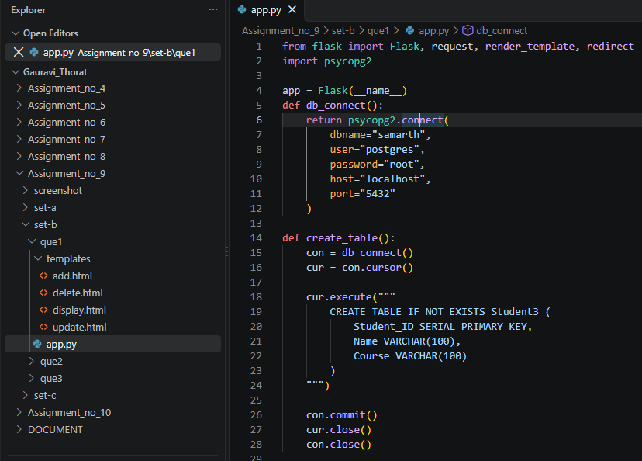
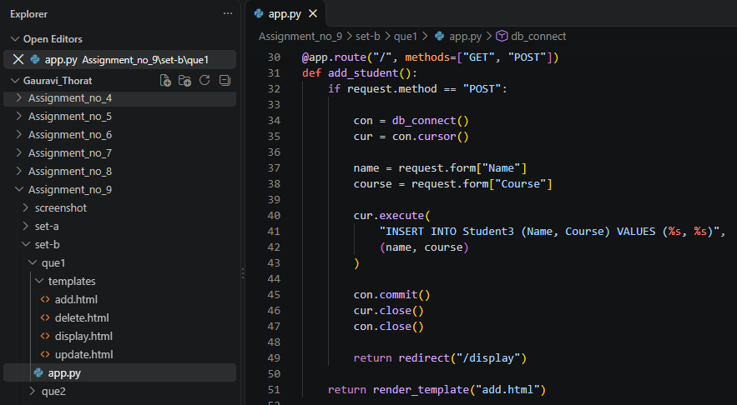
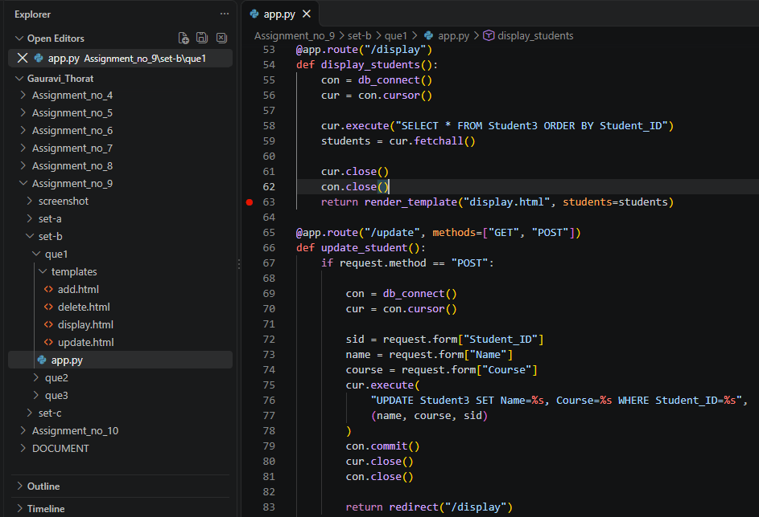

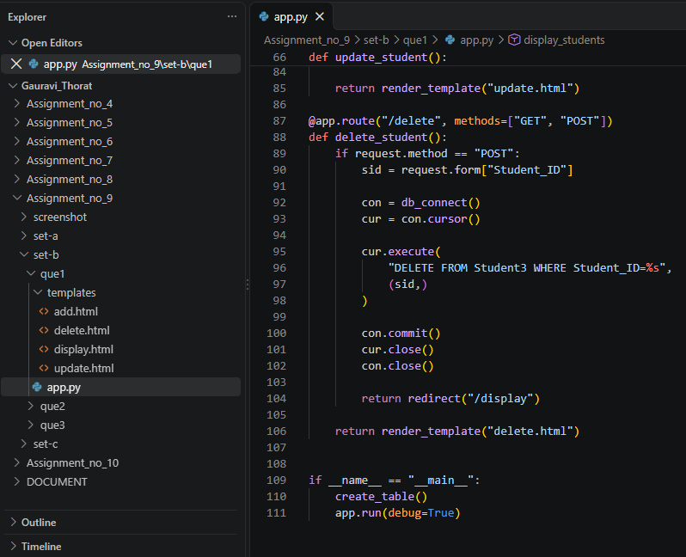
Add.html
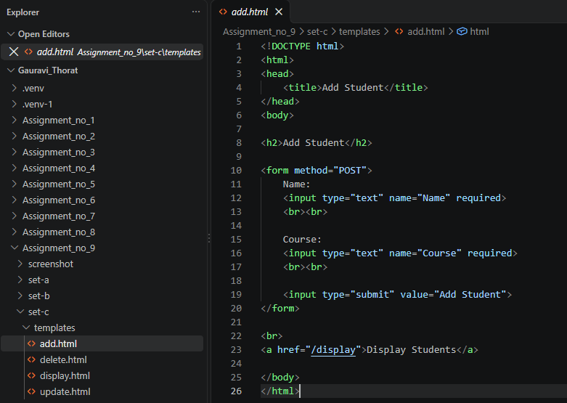
Delete.html
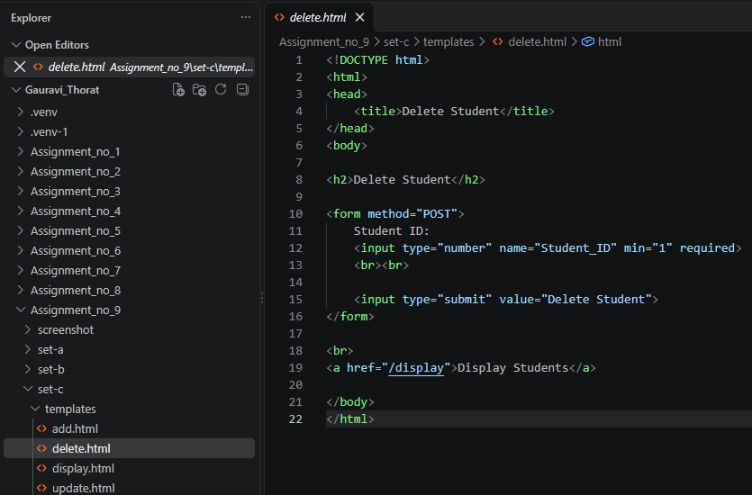
Display.html
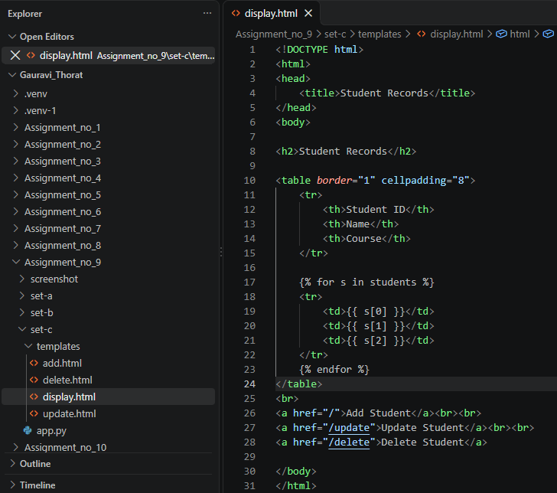
Update.html
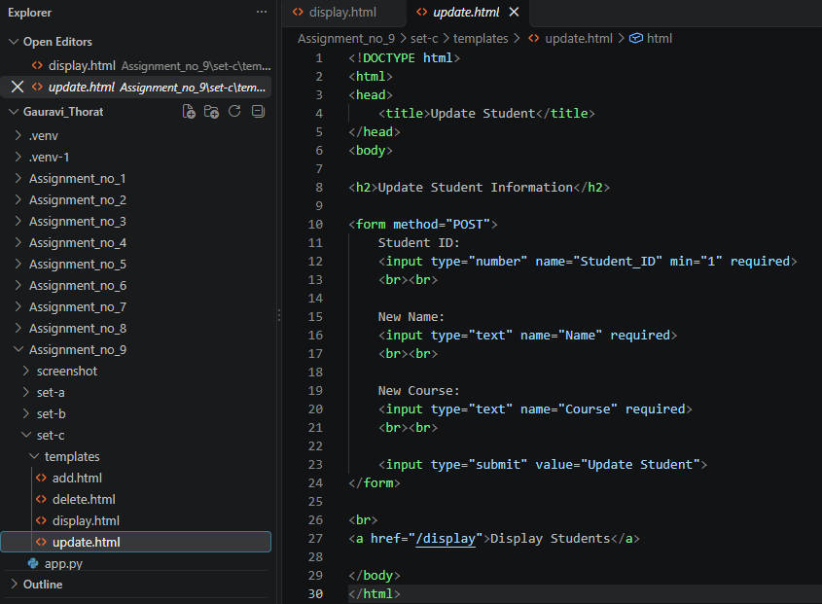
Output:
